ULTRASONIC SENSORS

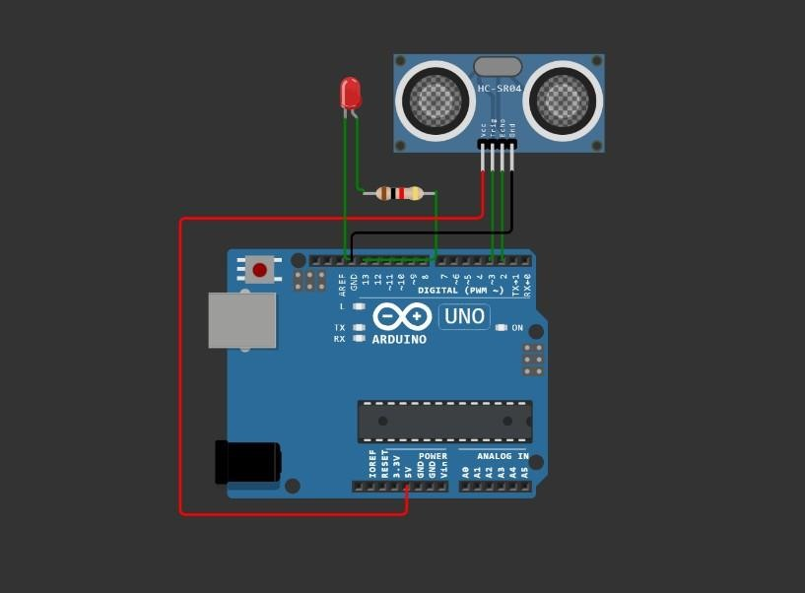

#define ECHO_PIN 2

#define TRIG_PIN 3 void setup() { Serial.begin(115200);

pinMode(LED_BUILTIN,OUTPUT); pinMode(TRIG_PIN, OUTPUT); pinMode(ECHO_PIN, INPUT);

}

float readDistanceCM() { digitalWrite(TRIG_PIN, LOW);

delayMicroseconds(2); digitalWrite(TRIG_PIN, HIGH); delayMicroseconds(10); digitalWrite(TRIG_PIN, LOW);

int duration = pulseIn(ECHO_PIN, HIGH); return duration * 0.034/2;

}

void loop() {

float distance = readDistanceCM();

bool isNearby = distance < 100 ; digitalWrite(LED_BUILTIN, isNearby); Serial.print("Measured distance: "); Serial.println(readDistanceCM());

delay(100);

}

https://wokwi.com/projects/346497866532913748